INSERT YOUR NAME AND ADDRESS HERE
Date: INSERT DATE

Re: Extension of Part 2 of the Health (Amendment) (No2) Act, 2021; and the Health and Criminal Justice (Covid-19) Amendment Act, 2021 (the “Acts”)

Dear [INSERT TD NAME],

As you will be aware, Part 2 of the Health (Amendment) (No. 2) Act, 2021 will expire unless extended by both House of the Oireachtas prior to 9 October 2021 and the Health and Criminal Justice (Covid-19) Amendment Act, 2021 will expire unless extended by both Houses of the Oireachtas prior to 9 November 2021.

I am aware that the Health Amendment No. 2 Act (which facilitated the introduction of domestic vaccine passports for indoor dining and will soon likely facilitate an extension of the premises that may ask for vaccine passports as a requirement of admission) was passed on 14 of July 2021, by 72 votes in favour and 66 votes against.
I am aware that the Health and Criminal Justice Act (which facilitates the closure of business and churches and can make it illegal for a person to leave their private dwelling without a reasonable excuse) was extended on 2 of June 2021, by 73 votes in favour and 68 votes against.
I am also acutely aware of how each and every TD voted in this regard and attach a record of same for completeness.
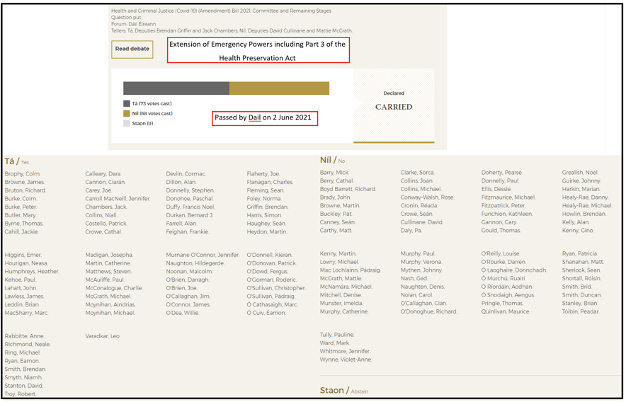

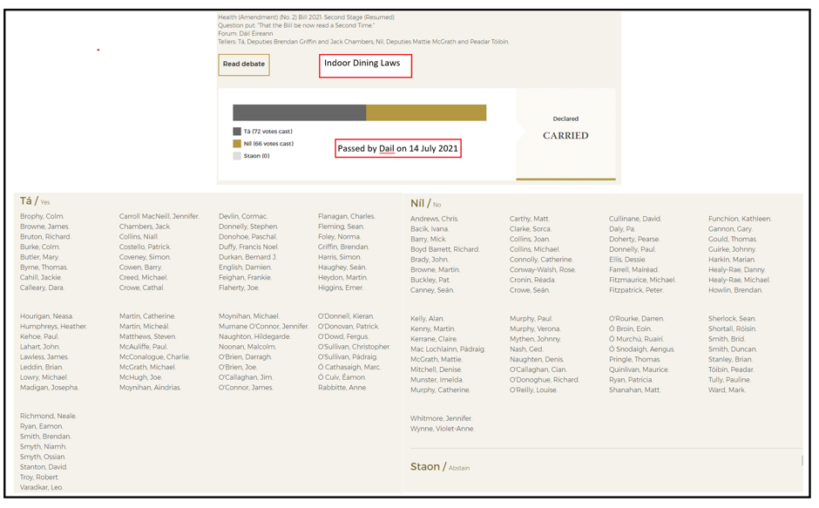
The purpose of this letter is to place on the record my firm disagreement with any extension of the Acts and to call upon you to VOTE AGAINST any extension of same (or alternatively with respect to those TD’s who are part of the Government, I ask that you abstain or do not present yourself at the vote).

Health (Amendment) (No. 2) Act, 2021
There can be no denying that the introduction of domestic vaccine passports has led to a significant divide and fracturing of society in Ireland, as many (including myself), consider that same seeks to eliminate a person’s fundamental rights, including: the right to free choice; the right to decide over one’s own body; the right to free and informed consent; the right to a dignified life; and the right to privacy.

Added to this is the fact that the egregious practice of refusing service to a person based on their private medical information, has now become acceptable. To put same into context, I wish to advise you of the following circumstances, that I have become aware of, where access to goods and services is being restricted, without legal mandate, due to a person’s private medical information:

- Access to organ transplant by Beaumont Hospital (noting that although the hospital has confirmed they do not operate a blanket refusal policy, it is clear that this denial is a smoke screen for a less transparent blanket refusal policy, which they say is based on individual risk assessments);
- Access to indoor restaurants, bars and cafes;
- Access to indoor canteens by students, on college premises;
- Access to hospitals in the capacity of a visitor;
- Access to indoor child soft play areas (unless parents are vaccinated);
- Access to training courses;
- Access to cinemas;
- Access to concerts;

I have also been made aware that some medical practices are suggesting that non vaccinated patients, should seek care elsewhere. If this is true (and as matters stand, I have no reason to doubt this), it is only a matter of time before anarchy descends, because if a medical practice feels they may operate such a blatantly discriminatory and immoral practice, it is only a matter of time before other businesses and services adopt the same policy. If this is to occur a section of society will become completely ostracised. I ask you why any person who is ostracised in this way should continue to abide by the law or pay taxes, if they are treated in such a contemptable manner. This is a serious question that you should ponder as the introduction and continuation of this legislation should not be underestimated in terms of its impacts on personal behaviour.
Health and Criminal Justice (Covid-19) Amendment Act, 2021
The introduction of the Health (Preservation and Protection and Other Emergency Measure in the Public Interest) Act 2020, in March 2020, will be recorded in history as the moment at which Ireland began its decent into tyranny.
The purpose of advising you of same is to appeal to your sense of self preservation, because I and many others will make it known who amongst our elected officials voted for the continuous erosion of our fundamental freedoms and in this regard, neither I, nor anyone else will have any regard for statements such as “I had to vote with the party”.
In circumstances where you are not swayed by self-preservation, I ask you to consider the following reasons as justification for voting against the extension of this legislation:
- It has caused an unacceptable level of collateral damage and suffering including in relation to physical and mental health, loneliness and isolation, increased domestic violence, and the livelihoods of many people;
- Public opinion is moving rapidly against the continuing lockdown which Part 3 enables, with the recent Kantar/Sunday Independent poll finding “huge frustration with the level of Covid restrictions”: 50% believe the lifting of restrictions is too slow;
- Human rights and civil liberties must be respected, even when this is difficult, noting that a liberal democratic society does not abandon its commitment to human rights and civil liberties as soon as that commitment becomes inconvenient. Instead, it maintains strong respect for those rights always;
- Lockdowns are not a normal pandemic response and, in fact, represent a radical departure from normal practice in responding to pandemics;
- The excessive resort to lockdown contravenes WHO Advice;
- Our Covid-19 mortality rate is similar to countries with much less stringent/prolonged lockdowns;
- Part 3 is not fit for purpose and is far too unbalanced, showing almost no regard for anything but Covid-19;
- Government persistently refuse to exercise sparingly even the most extreme of these powers;
- The case for continuing Part 3 could be justified only by evidence showing as a matter of certainty that those measures are necessary, effective and do more good than harm. Yet that is simply not the reality. Multiple published analyses indicate that lockdowns have little, if any, effect on Covid-19 mortality.;
- The original rationale for the restrictions (to “flatten the curve”) has long since passed.

As representatives elected by the people, for the people, it is essential for TD’s to maintain meaningful respect for fundamental rights and civil liberties, even when doing so presents challenges. For the avoidance of doubt, I confirm that when the next General Election takes place the paramount, decisive issue I will be concerned with is whether you did everything within your power to stop the extension of the Acts.
I require a response to this letter.
I await hearing from you and shall follow up upon this communication.
Yours Sincerely

__________________________
INSERT YOUR NAME HERE

